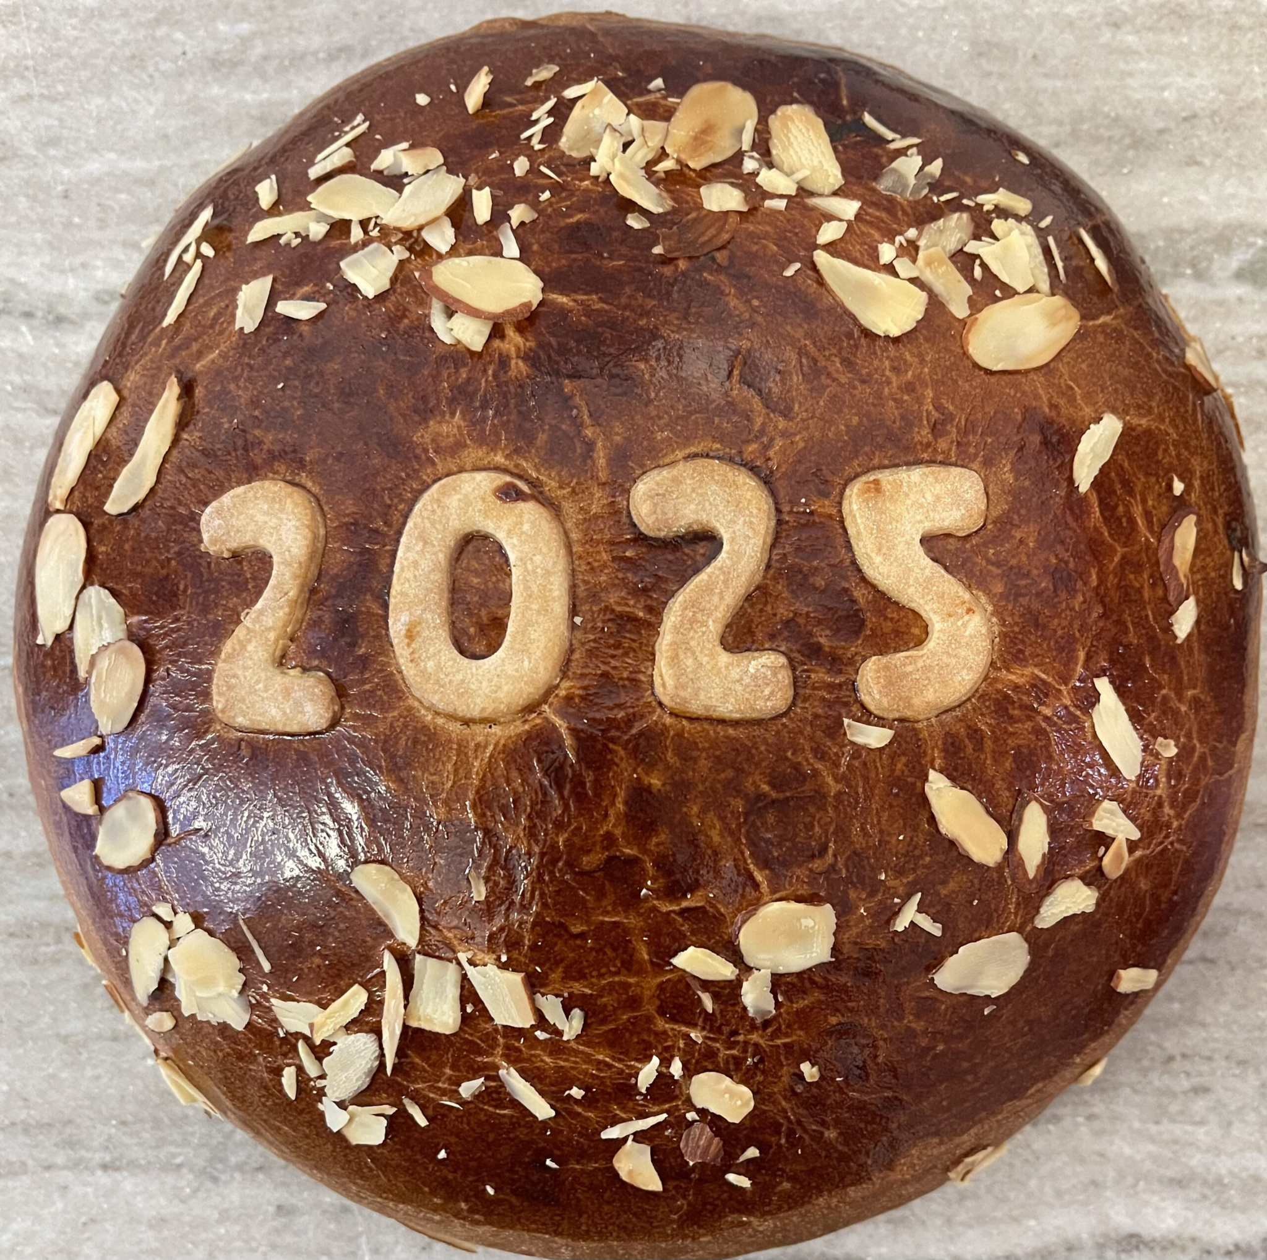

**The Chios Society of Washington DC**

**cordially invites you to the**

Annual Vasilopita Luncheon

Sunday, February 23, 2025 at 1:00 pm

Wildfire Tysons Galleria-

Third Floor near Saks Fifth Avenue

Adults - $50 Children $20

Family Style lunch to include an Appetizer, salad, 2 main courses,

2 sides, 2 desserts, vasilopita coffee, tea, and soda

Please disclose any allergies with your RSVP

Cash Bar Available

**RSVP by FEBRUARY 10, 2025**

**Due to the high demand of this event all RSVPs must be in advance**

**NO DAY-OF WALK INs WILL BE PERMITTED**

Send checks to 1 Atwell Ct, Potomac, MD 20854

Payable to The Chios Society of Greater Washington

Contact: Maria Stefanias 240-476-8597 [maria.stefanias@yahoo.com](mailto:maria.stefanias@yahoo.com)

John Costalas 240-994-1180 johnj.costalas@gmail.com

Visit our website at www.chios-society.com